ISCHEMIC COLITIS IN AN ADULT PATIENT WITH ATYPICAL HEMOLYTIC UREMIC SYNDROME (case report)

Ozerova O.S., Poltorykhina E.A., Vardanyan A.V., Maynovskaya O.A., Veselov V.V., Chernyshov S.V.
State Scientific Centre of Coloproctology, Moscow, Russia
(director – corresponding member of RAS, doctor of medical sciences, professor Yu.A. Shelygin)

The literature describes two types of hemolyticuremic syndrome – typical (postdiarrheal), associated with E. Coli (strain 0157:H7), and Shigelladysenteriae type I, etc., as well as atypical hemolyticuremic syndrome (AHUS),which is a rare life-threatening condition caused by uncontrolled complement activation due to mutations in the alternative pathway of complement components (AHUS).
Atypical hemolyticuremic syndrome (AHUS) is characterized by microangiopathic hemolytic anemia, thrombocytopenia, acute renal failure and affecting multiple organ systems, includingthe brain, gastrointestinal tract, lungs, and heart. Extra-renal manifestations of AHUS take place in 20% of patients including involvement of the central nervous system, cardiovascular system, lungs, skin and gastrointestinal tract. This case report describes a severe course of atypical hemolyticuremic syndrome which developed ischemic colitis in a 21-year-old female.

[Keywords: atypical hemolytic uremic syndrome, thrombotic microangiopathy, ischemic colitis, extrarenal manifestations]

Address for correspondence: Ozerova, O.S., State Scientific Centre of Coloproctology, Salama Adilya street, 2, Moscow, 123423; e-mail:info@gnck.ru

For citation: Ozerova O.S., Poltorykhina E.A., Vardanyan A.V., Maynovskaya O.A., Veselov V.V., Chernyshov S.V. Ischemic colitis in an adult patient with atypical hemolytic uremic syndrome. Koloproktologia. 2019; v.18, №2(68), pр.82-89

INTRODUCTION
Hemolytic uremic syndrome (HUS) was first described by Gasser C. et al. in 1995 and is characterized by a triad of symptoms: thrombocytopenia, hemolytic anemia and acute renal failure [1]. These features are components of thrombotic microangiopathy (TMA) characterized by generalized occlusion of microcirculatory vessels [2]. Clinically, TMA is manifested by thrombocytopenia, microangiopathic hemolytic Coombs-negative anemia (mechanical hemolysis), fever and lesion of various organs, mainly, kidneys and CNS, as well as the gastrointestinal tract, lungs, and heart [3,4]. Typical HUS (post-diarrheal) is associated with Shiga-toxin-producing E. Coli (STEC) (strain O 157:H7 and others), as well as Shigella dysenteriae type I and occurs in 85-95% of cases in children aged between 6 months and 5 years old [5,6]. The global incidence ranges from 0.2 to 8:100,000 people [3]. About 5% of all cases of HUS in children are associated with the pathogenic effect of Streptococcus pneumoniae, producing neuraminidase. The annual incidence is approximately 0.06 per 100,000 children under the age of 18 years old [7].
Atypical hemolyticuremic (AHUS, complement-HUS) refers to orphan diseases and is 5-10% in the structure of HUS [8].
The Ministry of Healthcare of the Russian Federation included AHUS in the list of rare (orphan) diseases (group: Blood diseases, hematopoietic organs and certain disorders involving the immune mechanism, ICD code D 59.3). Currently, 121 adults and 287 children are officially registered in Russia with a diagnosis of AHUS. According to the European resource of orphan diseases (Orphanet), the prevalence of AHUS is 1-9 cases per 1 million. In the US, the incidence of AHUS is 2 people per 1 million [9].
At the heart of this syndrome is a dysregulation of the complement system, leading to hyperactivation of its alternative pathway. According to the data of different registers, more than 1,000 patients with AHUS were found to have complement abnormalities [10-19]. The disease can be either familial (20%) or sporadic (80%) [10,11]. The type of inheritance in family AHUS is autosomal dominant or autosomal recessive. Most mutations are heterozygous. Due to incomplete penetrance of AHUS, in approximately 50% of the family members carrying the mutation, the disease does not manifest until 45 years old [7,12,20]. To date, mutations in the following genes of regulatory proteins and complement systems are known to play a role in the pathogenesis of the disease: complementary factor H (CFH) – 20-30%, plasma serine protease (CFI) – 4-10%, membrane cofactor protein (MCP or CD46) – 5-15%, thrombomodulin (THBD, endothelial glycoprotein) – 3-5%, and factor B (CFB) – 1-4%, C3 – 2-10% and anti - CFH antibodies – 6% [10-12,17-20]. All identified mutations in genes lead to excess C3-convertase production, which ultimately mediates endothelial cell lesion with the development of TMA. In 12% of patients with AHUS, various combinations of mutations are detected [11,17,19]. However, the etiology remains unknown in 30% of patients [19].
The manifestation of AHUS in childhood is observed in 40% of cases with the same frequency in boys and girls, while in adults the onset of the disease is noted in 60% of cases and prevails in female patients [10-13]. In 80% of cases, the disease begins suddenly, usually after the action of provoking factors, such as upper respiratory tract infections, viral gastroenteritis, pregnancy, rarely – chickenpox, H1N1 influenza virus [21-25]. Laboratory tests revealed anemia, thrombocytopenia, increased indicators of creatinine. However, in 20% of cases there is a gradual onset with subclinical anemia, thrombocytopeniasfluctuations.At diagnosis, renal function remains intact [7,19]. Extra renal manifestations of the disease occur in 20% of patients. The Central nervous system is most often involved (10%), in 3% of cases there is cardiac symptoms. Cases of peripheral vessels, respiratory system, gastrointestinal tract lesions (pancreatitis, hepatocellular insufficiency, gastrointestinal bleeding) are also described [7,26-28]. Fidan, K. et al. informed that, according to the Turkish national register for 2018, involvement of the gastrointestinal tract was observed in 20 (12%) cases and manifested in epigastric pain, vomiting, increased transaminases, bleeding, pancreatitis, intussusception, cholelithiasis [29]. Johnson, S. et al., according to the analysis of the data of the European pediatric research group on hemolytic uremic syndrome, revealed similar results in 72 patients with AHUS. Gastrointestinal lesions were registered in 8.5% of cases with clinical picture of perforation of the small intestine, pancreatitis, abdominal pain syndrome, cholelithiasis, laboratory revealed transaminases increase [30].
Diagnosis of AHUS presents significant difficulties due to the variability of the disease and the variety of symptoms.
The criteria for diagnosis are: the presence of Coombs-negative hemolytic anemia (excluding autoimmune anemia), thrombocytopenia, acute renal lesion, negative analysis for the presence of Shiga-toxin E. Coli, S. pneumoniae, normal indicators of ADAMTS13 metalloproteinase (at least 5% of the norm), which allows to run a differential diagnostic with thrombotic thrombocytopenic purpura (TTP). It is necessary to exclude autoimmune diseases (systemic lupus erythematosus, antiphospholipid syndrome, scleroderma), as well as other secondary TMA [2,3].
The main method of treatment of patients with AHUS until 2010 was plasma therapy [19]. Currently, the first-line therapy is the drug Eculizumab, which is an antibody to the C5 complement fraction blocking the activation of the terminal complement pathway. Prior to Eculizumab therapy, patients should be vaccinated against Neisseriameningitis, as a side effect of the drug is an increased risk of meningococcal meningitis [31].
In foreign publications, only one case of description of gastrointestinal tract lesions in the form of ischemic colitis against the background of atypical hemolyticuremic syndrome was found, and therefore the presentation of this clinical observation, in our opinion, is relevant.

CLINICAL OBSERVATION
Patient X., 21 years old, was admitted to the clinic in July 2018 with complaints of severe general weakness, dizziness, stool up to 8 times a day with a mixture of blood, abdominal pain, fever. From anamnesis it is known that she became ill acutely a week ago when there were sharp pains in the stomach after taking caffeine-containing drink, which was later joined by weakness, multiple liquid stool without blood admixture. She was hospitalized in an infectious diseases hospital. According to the conducted colonoscopy, it was impossible to exclude pseudomembranous colitis, a severe attack of ulcerative colitis, in connection with which the patient was transferred to our clinic. According to the physical study, the general condition was regarded as extremely severe, consciousness was not disturbed, there was adynamia, pale skin, subfebrile temperature, shortness of breath, BPD – 21 per minute, tachycardia (heart rate – 100 beats per minute), decrease in blood pressure to 90/60 mmHg. Attention was drawn to the sharp bloating in the absence of peritoneal symptoms, in connection with which the patient underwent an emergency colonoscopy without preparation of the intestine, in which the lumen of the blind, ascending intestine is expanded to 8-10 cm, the mucous membrane is pale pink, the vascular pattern is clear. The lumen of the transverse colon is sharply narrowed due to edema, on the walls of the intestine a hard-to-wash plaque of mucus and a large amount of fibrin are detected, a vascular pattern is completely absent. Mucous membrane in the form of "boiled meat", loose, in bluish color, spontaneous and contact bleeding are absent. Lumen of the intestine, from the left bend to the distal third of the sigmoid colon, expanded to 8-9 cm, edematous mucosa is hyperemic, vascular pattern cannot be traced. On the mucous membrane are determined areas of irregular shape, length 1.0-1.5 cm, in cyanotic color, with a touch of fibrin and without vascular pattern. The mucous membrane of the distal third of the sigmoid and rectum is pale pink, the vascular pattern is clear (Fig. 1).
On the basis of physical examination, laboratory data (anemia – Hb – 76.0 g/l, thrombocytopenia – 65.0 × 109/l), intoxication syndrome, as well as the results of colonoscopy, it was impossible to exclude the presence of signs of acute attack of colitis of unknown origin, as well as ischemic colitis with lesions of the transverse colon, descending and sigmoid colon.
Due to the development of toxic colon dilatation, the patient was urgently operated on. Intraoperatively, the colon from the right bend to the proximal third of the sigmoid colon expanded to 6 cm, edema, on the serous membrane there were injected vessels. The mesentery of the colon is swollen. Adjacent to the altered parts of the colon tissue swollen, diffusely bleeding. The intestinal wall at the level of the right colon, the distal third of the sigmoid colon intact (Fig. 2). In connection with the dire state of the patient, high risk of development of inflammatory complications and further spread of the pathological process into the adjacent unmodified segments of the colon, a subtotal colectomy with formation of ascendostoma and sygmostoma was performed.
On the 1st day after the operation, a decrease in the rate of diuresis was determined, in the clinical analysis of urine – proteinuria (protein – 5.00 g/l). On the 2nd day, despite intensive therapy, there was a progression of renal failure (increase in azotemia-increase in creatinine from 386 µmol/l to 510 µmol/l, urea from 22 mmol/l to 42 mmol/l, a sharp decrease in the rate of diuresis, the anemia remained (Hb – 86.0 g/l), thrombocytopenia (58.0 × 109/l), hypoalbuminemia (ALB – 19.0 g/l).), hyponatriemia (Na – 133.0 mmol/l), in this connection, the patient was transferred to the intensive care unit of a multidisciplinary hospital with a hemodialysis unit. At admission, the general condition was regarded as severe, stable. According to the APACHE scale - 17, the SOFA scale – 7 points. The body temperature was 36.6 C, respiratory rate 20 breaths per minute, SpO2 of 100% while breathing ambient air, AP 133/86 mmHg, heart rate 100 beats per minute, CVD 90 mmwс. In the general analysis of blood there is leukocytosis – 11.1 × 109/l, anemia – Hb – 74 g/l, thrombocytopenia – 25 × 109/l, in the biochemical analysis of blood – hypoproteinemia – 47.7 g/l, hypoalbuminemia – 23.4 g/l, increased creatinine – 552 µmol/l, AST – 62.9 U/l, amylase – 297 U/l (Table 1).

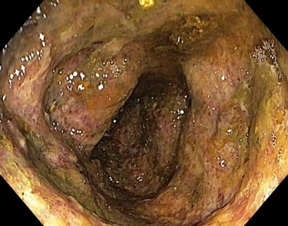
Figure 1. Endo-photo of the transverse colon: the mucosa sharply swelling, in bluish color, with massive overlays of fibrin

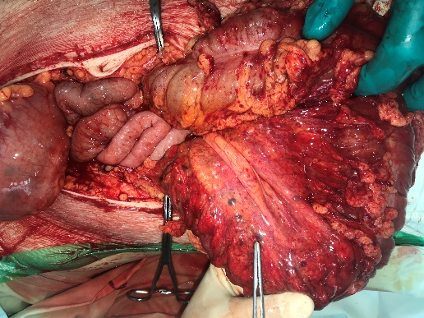
Figure 2. Intraoperative photography: the colon is enlarged to 6 cm, the wall and its mesentery are edematous, with injected vessels; diffuse bleeding of tissues is noted

Table 1. Dynamics of laboratory parameters
Main indicators | Hb | Ht | PLT | TP | ALB | BUN | CRE | TBIL | ALT | AST | AMY
Day 7 | 84,0 | 27,1 | 60,0 | 45 | 24 | 22 | 386 | 17,4 | 19 | 53 | 273
Day 9 | 86,0 | 26,9 | 58,0 | 45 | 19 | 42 | 493 | 17 | 10 | 32 | 245
Week 5 | 60 | 17 | 191 | 5 | 29 | 4,4 | 83 | 10,2 | 77 | 41 | 122
Week 6 | 92 | 25 | 228 | 51,7 | 31,2 | 6,7 | 81 | 6,6 | 23,1 | 21,7 | 114
Week 8 | 83 | 23 | 274 | 66 | 35,9 | 2,4 | 61,3 | 6,9 | 15,9 | 17,8 | 78,1

Ultrasound examination of abdominal cavity organs and kidneys revealed the signs of moderate edema of the renal parenchyma with contrast enhancement as well as bilateral pleural effusion, reduced airiness of the lower lobes of both lungs. Intensive therapy was carried out in the intensive care unit: antibiotic therapy, parenteral nutrition, correction of hypoalbuminemia, plasma/hemotransfusion, platelet transfusion, anticoagulant, decongestant and neuroprotective therapy.

According to the results of histological examination of the surgical preparation, there were marked violations of microcirculation and permeability of vessels with pronounced edema of the intestinal wall, the presence of ischemic changes in the mucosa (most likely, of a secondary nature), multiple blood clots, mainly in small vessels of the submucosal layer, the presence of blood clots in the small veins (taking into account their structure and prescription), which is most likely due to violations of blood flow in the intestinal wall and primary changes in the vessels of the microcirculatory bed. Given the clinical picture and morphological changes in the remote intestine, it is necessary to exclude the toxic genesis of the lesion, including hemolytic uremic syndrome (Fig. 4, 5a,b).
The patient was consulted by a nephrologist and was diagnosed with atypical hemolyticuremic syndrome. The patient underwent a number of laboratory studies to exclude autoimmune hemolytic anemia (negative direct Coombs test, schizocytes in the blood smear – 3%), as well as to exclude systemic autoimmune diseases (systemic lupus erythematosus, antiphospholipid syndrome), PCR negative results on intestinal infections, namely E. Coli). After that, it was recommended according to vital indications to conduct complementary-blocking therapy with Eculizumab, as well as vaccination against meningococcal infection (Menactra 0.5 ml). On the 6th day, the patient developed a cerebral infarction in both occipital lobes. On the 20th day, when trying to swallow liquid with a deflated cuff of the tracheostomy tube, choking, fluid flow through the tube was noted, esophagogastroduodenoscopy was performed, esophageal-tracheal fistula was diagnosed, intubation of the small intestine was carried out.
In connection with the tracheo-esophageal fistula remained, on the 30thday (the 4thweek after transferring to the general hospital) surgery was performed comprising cervicotomy, separation tracheo-esophageal fistula, combined blend gastrostomy, tracheal intubation with the bronchoscope.
The postoperative period was uneventful, antibiotic therapy was stopped at the 6thweek, the general condition stabilized, and the patient was transferred to the surgical department. When transferred to the department, the following laboratory parameters were observed: Hb 91.0 g/l, platelets – 209 × 109/l, total protein – 51.7 g/l, albumin – 31.2 g/l, urea – 5.4 mmol/l, creatinine – 96 µmol/l, total bilirubin – 11.7 µmol/l, sodium – 129 mmol/l.By the 8th week of stay in the general hospital, full recovery of renal nitrogen function and normalization of hematological parameters were noted (Diagram1).
The patient was discharged under the supervision of a nephrologist, surgeon and therapist at the place of residence, followed by entry into the register of patients with orphan diseases. Further pathogenetic supportinganti-recurrence therapy was continued.

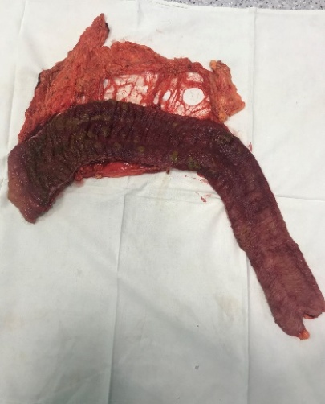а | 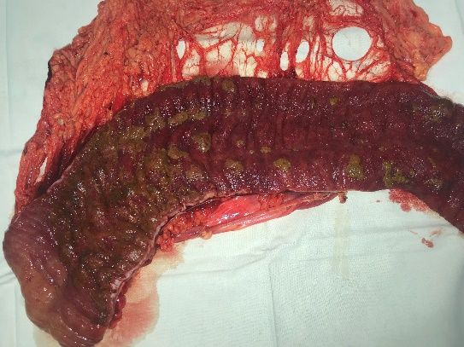б
Figure 3 (a,b). Macro-preparation of the resected intestine. Mucous membrane in dark red color with massive overlays of greyish-green films, with confluent hemorrhages, edematous, rude folds. A clear border of the affected and healthy part of the intestine is visible. b)Fragment of a large omentum with moderately full-blooded vessels

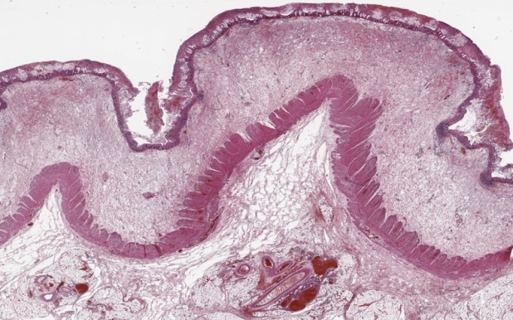
Figure 4. Intestinal slice. The wall of the colon with distinctedema of the submucosal layer, ischemic changes in the mucosa with massive overlays of fibrin masses on the surface. Magnified ×4, stained with hematoxilin and eosin

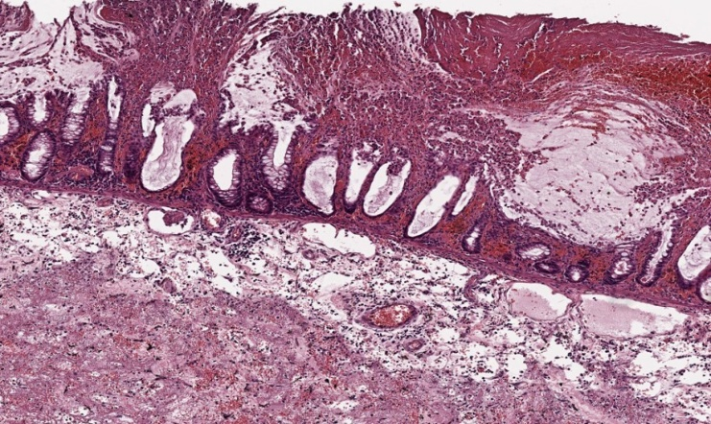 | 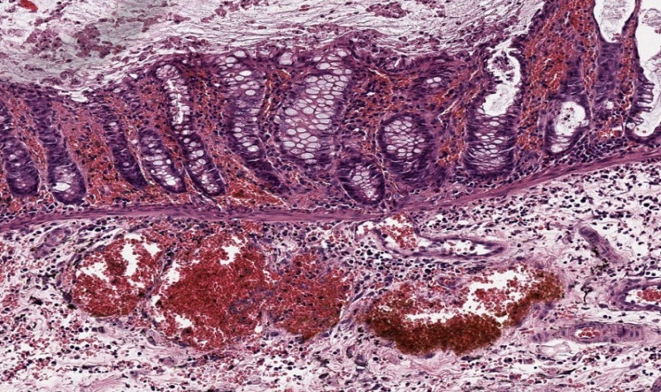
Figure 5 (a,b). Manifestations of microangiopathy in the intestinal wall: diapedesis and focal hemorrhages in the mucous and submucosal layers, red and fibrin clots in small vessels of the submucous layer (a – magn.×50, b– magn.×100, stained with hematoxilin and eosin)

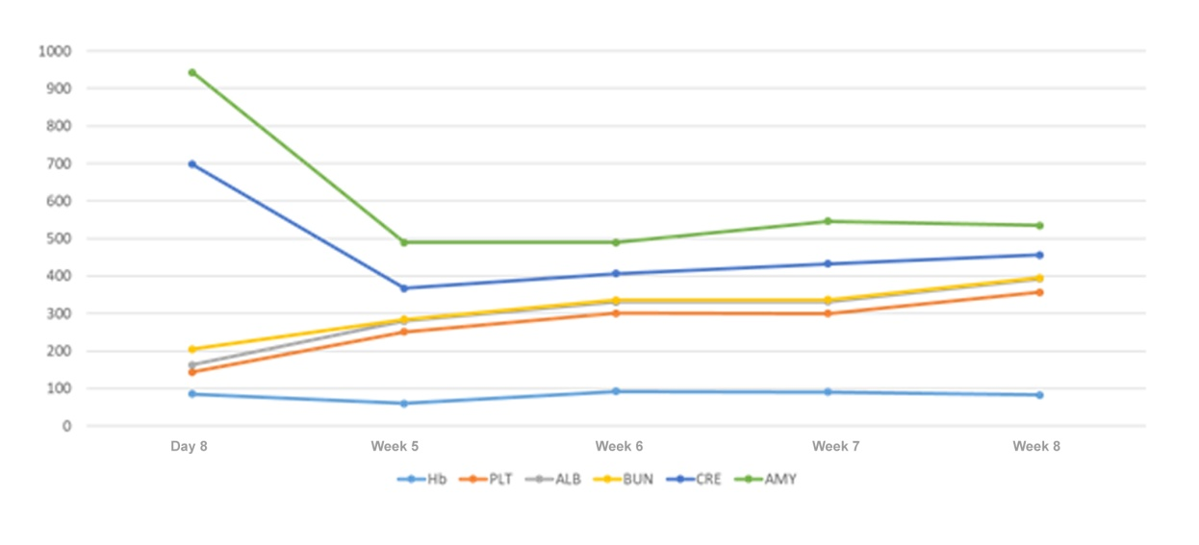
Diagram 1. Dynamics of laboratory parameters before and after eculizumab therapy

DISCUSSION
In the presented clinical observation, we were faced not only with a rare, life-threatening disease, but also with its non-standard course. According to the literature data, diarrhea in the prodromal period of the disease is a characteristic symptom of hemolytic uremic syndrome associated with enteropathogenic strains of colon bacillus and occurs in 90-95% of cases [2,3,7]. In our observation, the onset of the disease was preceded by diarrhea with an admixture of blood, which led to difficulties in diagnosis. The disease manifestation occurred on day 6, which is comparable with the literature data (2-14 days) [2,3]. In the described observation, the extrarenal manifestation was the lesion of the gastrointestinal tract, which contradicts the literature data, according to which the main extrarenal manifestation is the lesion of the central nervous system [7,26-28].
Involvement of the gastrointestinal tract may be manifested by pancreatitis, intestinal bleeding, hepatocellular insufficiency. In the literature, we found only one case of the course of AHUS in a 50-year-old patient with severe CNS and gastrointestinal lesions in the form of ischemic pancolitis, which required total colectomy (Ohanian, M. et al.) [32]. In our clinical observation, the second extrarenal manifestation was a CNS lesion in the form of a cerebral infarction, manifested by a generalized convulsive seizure by the end of the 2nd week from the onset of the disease. Identical CNS lesions are mentioned in a number of publications [29,30,34]. The pathogenesis of CNS lesion is associated with multifocal TMA, arterial hypertension, metabolic disorders caused by renal insufficiency (uremia, electrolyte imbalance) [29,33].It should be also noted that the timely initiation of pathogenetic therapy is a key point in the successful treatment of the disease. According to the literature, chronic renal insufficiency develops in 50% of cases, and mortality rates in the acute period of the disease range from 5 to 25% [2,35]. In our case, at the time of discharge, the phenomena of acute renal lesion were completely stopped.

CONCLUSION
Despite the rarity of AHUS, doctors of any specialty in their clinical practice may face this serious pathology. Due to the duration of molecular genetic research to detect mutations in the acute phase of the disease, it is almost impossible to obtain results. However, in the presence of anemia, thrombocytopenia, renal dysfunction in conjunction with the negative results of tests for the presence of Shiga-toxin E. Coli, it is necessary to exclude AHUS, since the immediate start of pathogenetic therapy has a significant impact on the successful outcome of the disease.

REFERENCES
- Gasser C, Gautier E, Steck A et al. Hemolytic-uremic syndrome: bilateral necrosis of the renal cortex in acute acquired hemolytic anemia. Schweiz Med Wochenschr.1955; 85(38-39):905–909.
- Tsigin AN, Vashurina TV, Margieva TV et al. Federal clinical guidelines to provide care to children with hemolytic uremic syndrome. Paediatric pharmacology. 2015; no.12(4), pp.447–455 (in Russ.).
- Kozlovskaya NL, Emirova HM, Pankratenko TE et al. Draft of the clinical guidelines for the diagnosis and treatment of atypical hemolytic uremic syndrome. Scientific society of the nephrologists of Russia. 2014. (in Russ.).
- Makovetskaya GA, Mazur LI, Gasilina ES et al. Monitoring of children’s healthsuffered hemolytic uremic syndrome, as a factor in preventing development and progression of chronic kidney disease. Paediatrics.2011; no.90(3), pp.6-12 (in Russ.).
- Salvadori M, Bertoni E. Update on hemolytic uremic syndrome: diagnostic and therapeutic recommendations. World J Nephrol. 2013;2(3):56–76.
- Fakhouri F, Zuber J, V.Fremeaux-Bacchi V et al. Haemolyticuraemic syndrome. Lancet. 2017;390:681–696.
- Cody EM, Dixon BP. Hemolytic Uremic Syndrome. Pediatr Clin N Am. 2019;66(1):235–246.
- Makarova TP, Emirova HM, Zverev DV et al. Atypical hemolytic uremic syndrome. Practical medicine.2012; no.7(62), pp.61 (in Russ).
- Constantinescu AR, Bitzan M, Weiss LS, Christen E, Kaplan BS et al. Non-enteropathi chemolytic uremic syndrome: causes and short-term course. Am J Kidney Dis. 2004;43:976–982.
- Sellier-Leclerc AL, Fremeaux-Bacchi V, Macher MA, Niaudet P, et al. Differential impact of complement mutations on clinical characteristics in atypical hemolytic uremic syndrome. J Am Soc Nephrol. 2007;18:2392–2400.
- Noris M, Caprioli J, Bresin E, Mossali C, et al. Relative role of genetic complement abnormalities in sporadic and familial aHUS and their impact on clinical phenotype. Clin J Am Soc Nephrol. 2010;5:1844–1859.
- Sullivan M, Erlic Z, Hoffmann MM, Arbeiter K, et al. Epidemiological approach to identifying genetic predispositions for atypical hemolytic uremic syndrome. Ann Hum Genet. 2010;74:17–26.
- Caprioli J, Noris M, Brioschi S, Pianetti G, et al.Genetics of HUS: the impact of MCP, CFH and IF mutations on clinical presentation, response to treatment, and outcome. Blood. 2006;108:1267–1279.
- Westra D, Volokhina E, van der Heijden E, Vos A, et al. Genetic disorders in complement (regulating) genes in patients with atypical hemolytic uraemic syndrome (aHUS). Nephrol Dial Transplant. 2010;25:2195–2202.
- Esparza-Gordillo J, Goicoechea de Jorge E, Buil A, Carreras Berges L, et al. Predisposition to atypical hemolytic uremic syndrome involves the concurrence of different susceptibility alleles in the regulators of complement activation gene cluster in 1q32. Hum Mol Genet. 2005;14:703–712.
- Dragon-Durey MA, Blanc C, Marliot F, Loirat C, et al. The high frequency of Complement Factor H-Related CFHR1 Gene deletion is restricted to specific subgroups of patients with atypical Haemolytic Uraemic Syndrome. J Med Genet. 2009;46:447–450.
- Bienaime F, Dragon-Durey MA, Regnier CH, Nillson SC, et al. Mutations in components of complement influences the outcome of Factor Iassociated atypical hemolytic uremic syndrome. Kidney Int. 2009;77:339–349.
- Maga TK, Nishimura CJ, Weaver AE, Frees KL, Smith RJ. Mutations in alternative pathway complement proteins in American patients with atypical hemolytic uremic syndrome. Hum Mutat. 2010;31:1445–1460.
- Loirat C, Fremeaux-Bacchi V. Hemolytic uremic syndrome. Nephrology.2012;V.16: no.2. (in Russ.).
- Kavanagh D, Goodship T. Genetics and complement in atypical HUS. Pediatr Nephrol. 2010;25:2431–2442.
- Allen U, Licht C. Pandemic H1N1 influenza A infection and (atypical) HUS-more than just another trigger? Pediatr Nephrol. 2011;26:3–5.
- Caltik A, Akyuz SG, Erdogan O, Demircin G. Hemolytic uremic syndrome triggered with a new pandemic virus: influenza A (H1N1). Pediatr Nephrol. 2011;26:147–148.
- Noris M, Remuzzi G. Atypical hemolytic-uremic syndrome. N Engl J Med. 2009;361:1676–1687.
- Kwon T, Belot A, Ranchin B, Baudouin V, Fremeaux-Bacchi V, Dragon-Durey MA et al. Varicella as a trigger of atypical haemolyticuraemic syndrome associated with complement dysfunction: two cases. Nephrol Dial Transplant. 2009;24:2752–2754.
- Fakhouri F, Roumenina L, Provot F, Sallee M, Caillard S, Couzi L, Essig M et al. Pregnancy-associated hemolytic uremic syndrome revisited in the era of complement gene mutations. J Am Soc Nephrol. 2010;21:859-867.
- Loirat C, Fremeaux-Bacchi V. Atypical hemolytic uremic syndrome. Orphanet J Rare Dis. 2011;6:60.
- Sallee M, Daniel L, Piercecchi MD, Jaubert D, Fremeaux-Bacchi V et al. Myocardial infarction is a complication of factor H-associated atypical HUS. Nephrol Dial Transplant. 2010;25:2028–2032.
- Kaplan BS, Garcia CD, Chesney RW, Segar WE et al. Peripheral gangrene complicating idiopathic and recessive hemolytic uremic syndromes. Pediatr Nephrol. 2000;14:985–989.
- Fidan K, Goknar N, Gulhan B, Melek E et al. Extra-Renal manifestations of atypical hemolytic uremic syndrome in children. Pediatric Nephrology. 2018;33(8):1395–1403.
- Johnson S, Stojanovic J, Ariceta G, Bitzan M, Besbas N, Frieling M et al. An audit analysis of a guideline for the investigation and initial therapy of diarrhea negative (atypical) hemolytic uremic syndrome. Pediatr Nephrol. 2014;29:1967–1978.
- Ram S, Lewis LA, Rice PA. Infections of people with complement deficiencies and patients who have undergone splenectomy. Clin Microbiol Rev. 2010;23:740–780.
- Ohanian M, Cable C, Halka K. Eculizumab safely reverses neurologic impairment and eliminates need for dialysis in severe atypical hemolytic uremic syndrome. Clin Pharmacol. 2011;3:5–12.
- Hofer J, Rosales A, Fischer C, Giner T. Extra-Renal Manifestations of Complement-Mediated Thrombotic Microangiopathies. Frontiers in Pediatrics. 2014;2(97):1-16.
- Riedl M, Fakhouri F, Le QM, Noone DG, Jungraithmayr TC et al. Spectrum of complement-mediated thrombotic microangiopathies: pathogenetic insights identifying novel treatment approaches. Semin Thromb Hemost. 2014;40(4):444–464.
- Papayan AV, Natochin YuV, Levanovich VV et al. edited by AV Papayan, ND Savenkova. Clinical Nephrology of childhood: the guide for physicians. M.:Levsha, St. Petersburg. 2008, p.599. (in Russ.).

